**Use the two methods below to normalize the following group of data:**

**200, 300, 400, 600, 1000**

1. **min-max normalization by setting min = 0 and max = 1**

**Ans:**

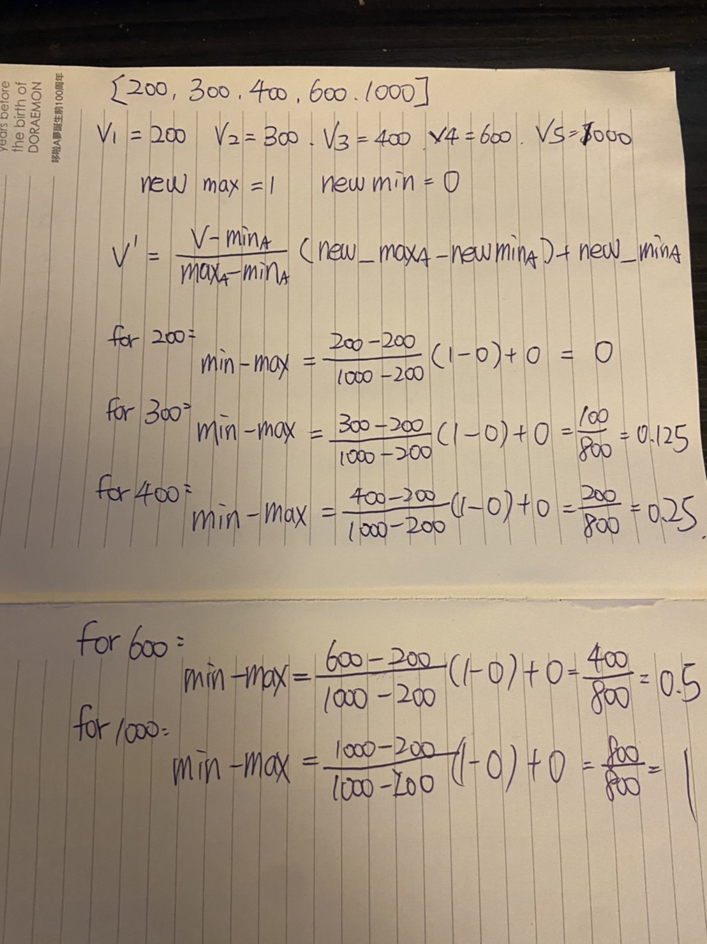

**Data : [200, 300, 400, 600, 1000]**

**(0,1)** **Normalization : [0, 0.125, 0.25, 0.5, 1]**

1. **z-score normalization**

**A**ns:

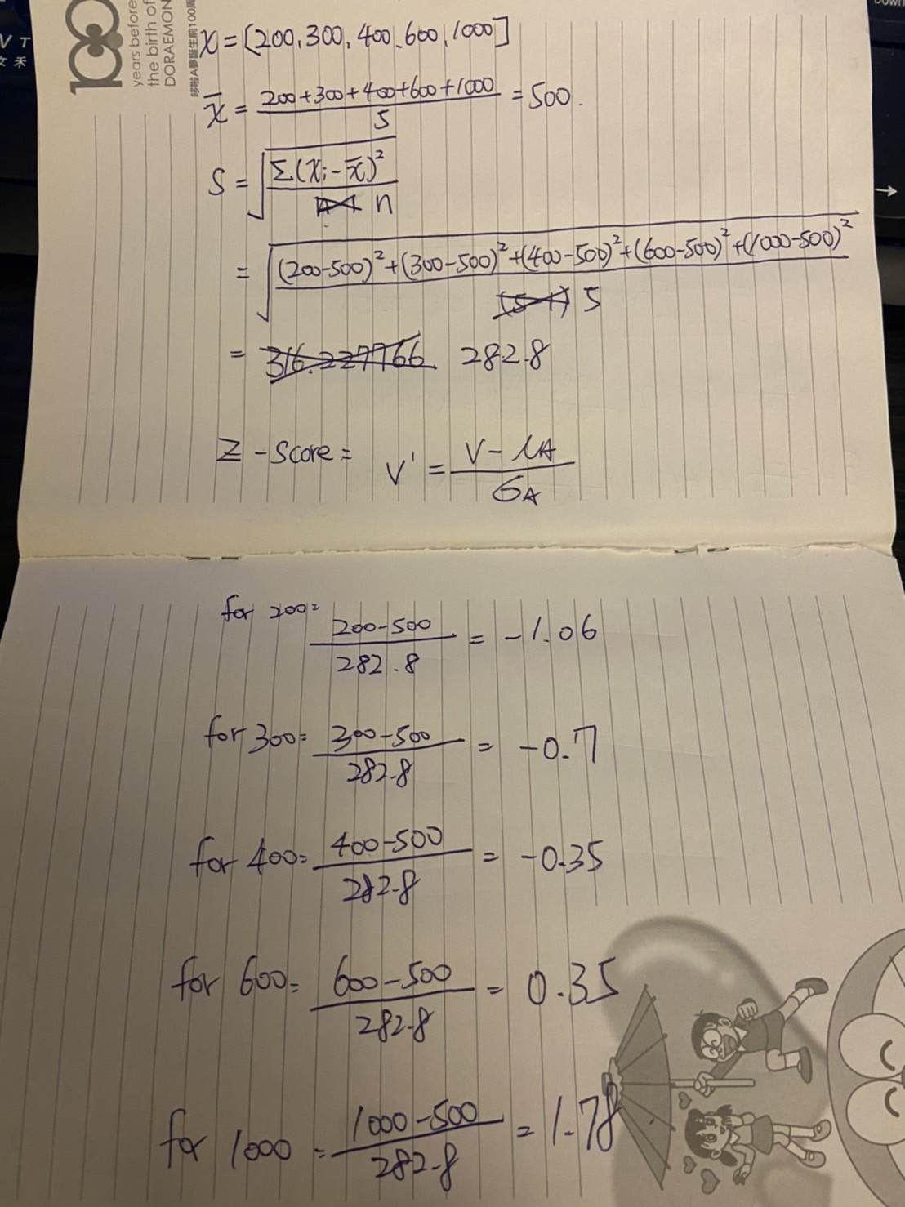

**Data : [200, 300, 400, 600, 1000]**

**Z-score : [-1.06, -0.7, -0.35, 0.35, 1.78]**

**LOAD DATA**

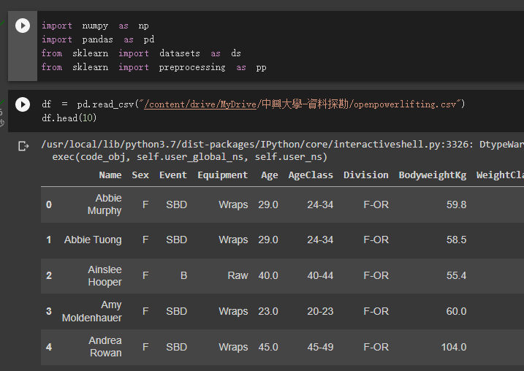

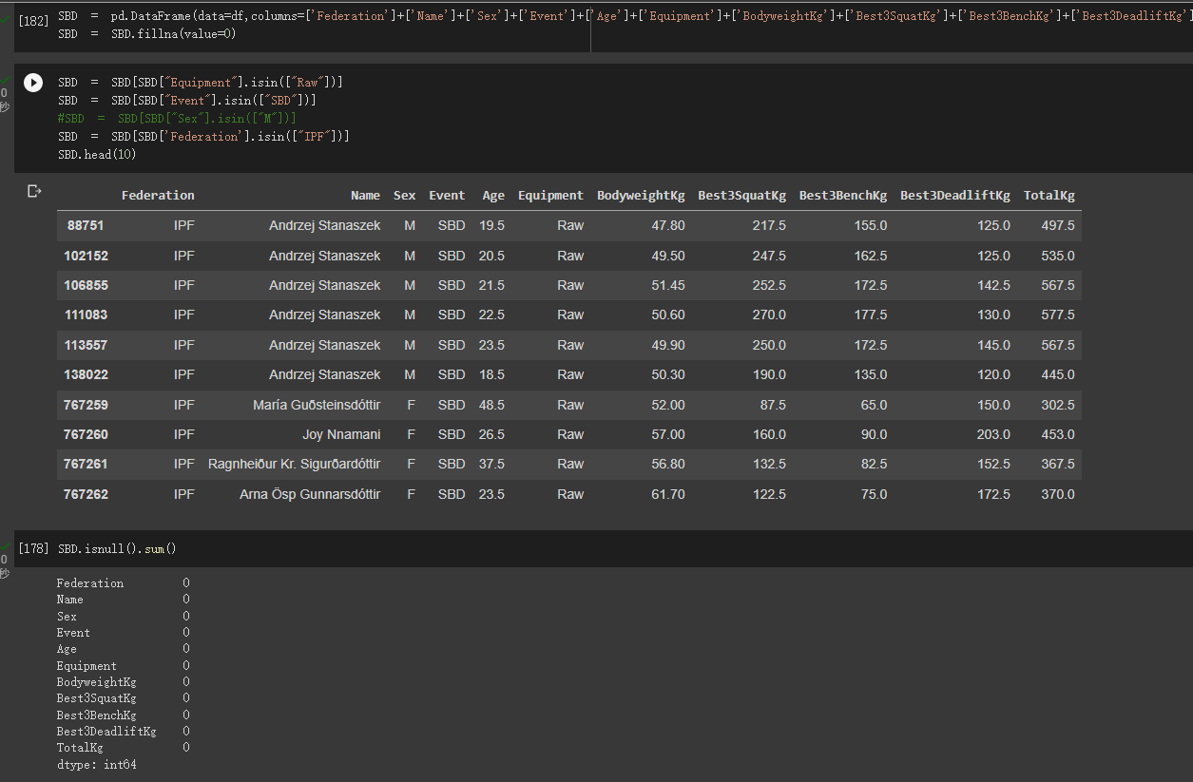

LOAD Data 2

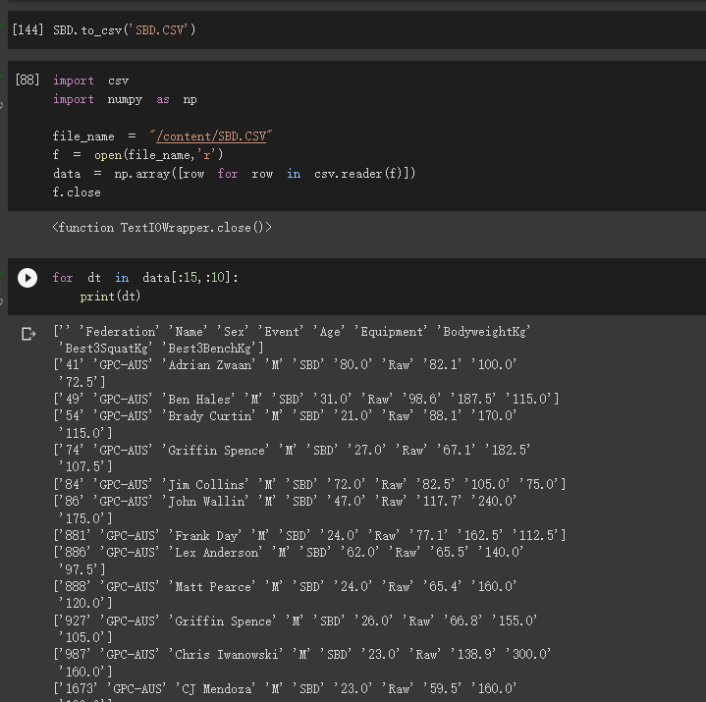

Standardization

SCALE

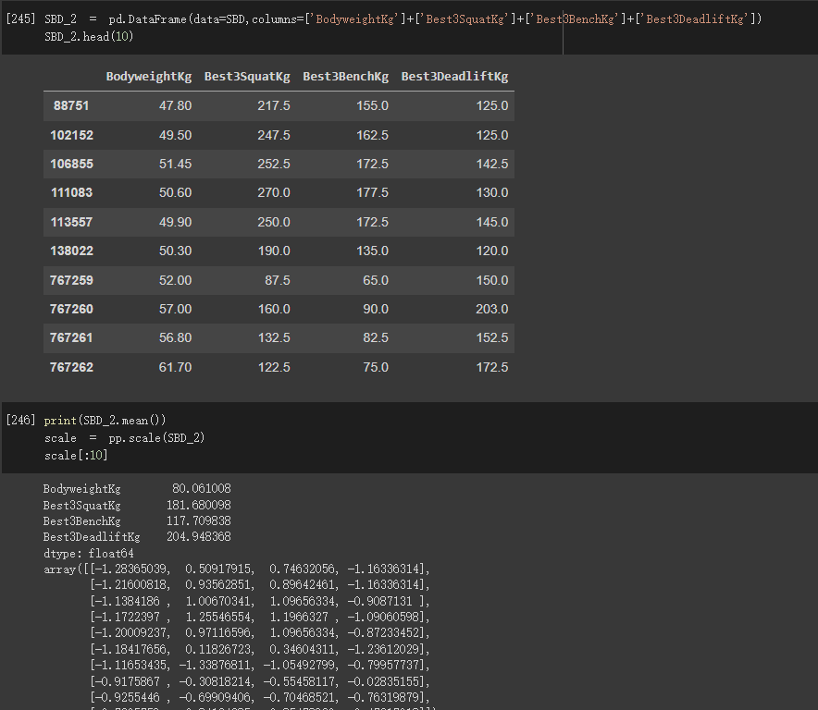

Normalize

Binarize

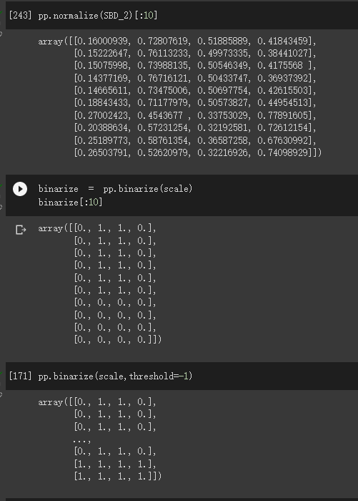

LabelEncoder

Applymap

FuntionTransformer

